**namName: _______________________________________**

**Python Activity 2: Input and Variables**

|  |
| --- |
| **Learning Objectives**  Students will be able to:  *Content:*   * Explain how to input data using Python * Explain the meaning and purpose of a variable * Determine if a variable name is valid * Explain concatenation and the use of “+”   *Process:*   * Create **input** statements in Python * Create *Python* code that prompts the user for data and stores it in a variable * Create valid and good variable names   **Prior Knowledge**   * Material covered in Activity 1 |

**Critical Thinking Questions:**

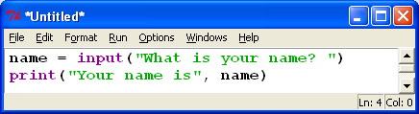

1. Enter and execute the Python program. What is printed on the screen when the Python program is executed?

“What is your name?”

|  |
| --- |
| **FYI: input() and print()** are ***functions*** in Python. |

1. Examine the first line of Python program: **name = input(“What is your name? ”)**

a. What appears on the screen when this line of code is executed?

What is your name? : if you enter your name it then says “Your name is Cameron”

|  |
| --- |
| **FYI:** The words that appear on the screen and tell the user what to enter are known as a ***prompt***. |

|  |
| --- |
| **FYI: name = input(“What is your name? ”)**  The word **name** in the Python code is a ***variable*** *– a name given to a memory location used to store data.* |

b. What happens to the data the user entered?

It is printed as follows “Your name is Cameron”

3. Explain the errors that occur when you execute each of the following lines of Python code.

a. name? = input(“What is your name?”)

the question mark causes a syntax error.

b. your name = input(“What is your name?”)

error invalid syntax.

c. 1st_name = input(“What is your name?”)

syntax error invalid decimal literal.

d. from = input(“Where were you born?”)

syntax error

4. Examine the errors that occurred when executing the lines of code in question 3. Then examine the following lines of valid code.

name2 = input(“What is your name?”)

your_name = input(“What is your name?”)

yourName = input(“What is your name?”)

List the rules that you need to follow to create a valid ***variable*** name.

You cannot start a line of code with a number. You cant use variables with symbols other than the underscore.

5. Are the following variable names **valid**? Are they **good** names? Why or why not?

|  |  |
| --- | --- |
| **Variable name** | **Comments about variable name** |
| price | It is valid. It’s basic but for an uncomplicated code, it will suffice. |
| costoffirstitem | Yes, it works but you might want to do camel caps for ease of interpretation and reading for the people reading the code. |
| Ic | Yeah, it works. Just depends on whether or not this is interpretable is dependent on your team and use case. |
| firstName | Perfect. Works are specific and easily interpretable by anyone that may use the code. |

6. Execute the following lines of code. Is the output what you would expect? Why or why not?

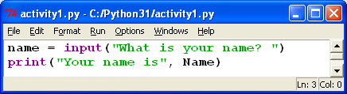 Yes it is. It asks what your name is then

Repeats it back to you.

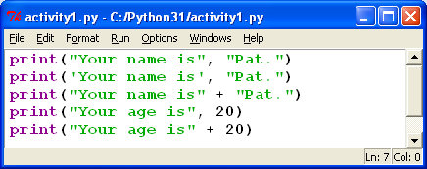

7. Use the following set of Python statements to answer the questions below.

a. State the output for each of line of code.

“Your name is Pat.” “Your name is Pat.” “Your name isPat” “Your age is 20” “Your age is 20”

b. How are the first two print statements different? Does the difference affect the output?

The first set of string literal uses single quotes on the second line of code. The output is identical.

c. Notice that some statements include a comma (,) between the two literals being printed and some statements use a “+”. Do they produce the same output?

The plus adds the 2 sets of string literal right next to each other. The comma adds exactly one space.

d. Explain the purpose of the comma.

The comma adds exactly one space between the 2 sets of string literal.

e. Why does the last print statement crash the program? What would you do to correct it?

You can only add string literal to string literal and int to int. add a comma and it works just like the line of code above it did.

|  |
| --- |
| **FYI:** “+” **concatenates** two strings. The strings can be string literals or a variable containing string literals. |

8. State what is displayed on the screen when the following program is executed:

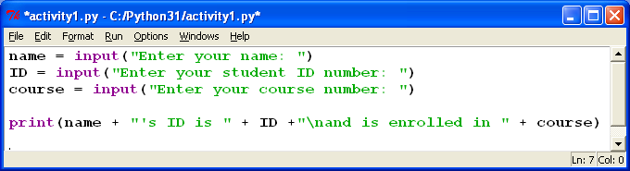

When the questions are answered it says “Cameron Willis’s ID is 12345 and is enrolled in 54321”

**9.** What caused the output in the print statement in question 8 to be printed on more than one line?

The \n command indicates that everything following should drop down a line.

**Application Questions: Use the Python Interpreter to input your code and check your work**

1. State a good variable name for an employee’s ID number. “EmployeeID”

2. Write a line of Python code that prompts the user for the name of their favorite ice cream and stores it in a valid variable name. FavIceCr=input("What is your favorite ice cream flavor?")

3. **Crazy Sentence Program**. Create a program that prompts the user for the name of an animal, a color, the name of a vehicle, and the name of a city. Then print a sentence that contains the user input in the following order. Include the additional words in the sample output as part of your output. Example: Assume the user enters the words: tiger, green, motorcycle, and Wildwood. The output would be: ***The* green tiger *drove the* motorcycle *to* Wildwood.**

animal=input("pick an animal: ")

color=input("Pick a color: ")

vehicle=input("Pick a make and model of vehicle: ")

city=input("Pick any city in the world: ")

print("the",color,animal,"had driven the",vehicle,"into a building in",city, "at a downtown intersection.")